**FORMAN CHRISTIAN COLLEGE**

**(A CHARTERED UNIVERSITY)**



**Embedded Systems (CSCS 306)**

**FALL-2019**

**LAB-00**

**Arduino Basics**

**Group Members:**

* Mohammad Usman 20-10558
* Haris Naseer 20-10612
* Abeer Butt 20-10596

**Introduction:**

Aim of the lab was to test Arduino programming and using the Arduino IDE. It tested our basic C programming and taking input and giving output to the user using the serial monitor. We had to use new methods for input and output from the Serial class.

This lab consists of two parts LabTask1, LabTask2 and LabTask3.

**LabTask1:** In Task1, we took the size of an array and its elements from the user. Then, the program should display the elements of array by iterating over the array.

**LabTask2:** Task2 was same as Task1, the only difference was that we had to create functions for input processing (size & elements of array) and output (elements of array) to make the code more readable and manageable.

**LabTask3:** In Task3, we used the same functions as defined in Task2, the only addition was to make a function which should reverse an array and then display it’s elements.

**Working Code:**

**LabTask1:**

char c; // used for clearing the buffer (Serial.available)

void setup()

{

// put your setup code here, to run once:

Serial.begin(9600);

// getting array size

Serial.print("Enter Array size: ");

while (Serial.available() == 0);

int sz = Serial.parseInt( );

Serial.print(sz);

Serial.println();

// initializing array

int arr[sz];

int i = 0;

Serial.print("Initializing array ");

while (i < sz)

{

Serial.print(".");

arr[i] = 0;

i++;

delay(1000);

}

Serial.println();

Serial.println("Array has been initialized Successfully.");

// getting values for array

Serial.println("Enter Values in the array: ");

i = 0;

while (i < sz)

{

Serial.print("arr[");

Serial.print(i);

Serial.print("] = ");

c = Serial.read();

while (Serial.available() == 0);

arr[i] = Serial.parseInt();

Serial.print(arr[i]);

Serial.println();

i++;

}

// displaying values the user entered

Serial.println("You have Entered:");

i = 0;

while (i < sz)

{

Serial.print(arr[i]);

Serial.print(" ");

i++;

}

}

void loop()

{

// put your main code here, to run repeatedly:

}

**LabTask2:**

int sz;

char c;

int *arr;

void setup()

{

// put your setup code here, to run once:

Serial.begin(9600);

sz = get_size(); // get size of array from use

init_array(sz); // initialize array

populate_array(arr, sz); // insert elements in array

display_array(arr, sz); // display elements of array

}

void loop()

{

// put your main code here, to run repeatedly:

}

// function to get array size from user

int get_size()

{

Serial.print("Enter Array size: ");

while (Serial.available() == 0);

int sz = Serial.parseInt();

Serial.print(sz);

Serial.println();

return sz;

}

// function to initialize array with 0

void init_array(int siz)

{

arr = (int *)malloc(sizeof(int) * sz);

int i = 0;

Serial.print("Initializing array ");

while (i < siz)

{

Serial.print(".");

arr[i] = 0;

i++;

delay(1000);

}

Serial.println();

Serial.println("Array has been initialized Successfully.");

}

// function to get elements from user and insert in array

void populate_array(int arr[], int siz)

{

Serial.println("Enter Values in the array: ");

int i = 0;

while (i < siz)

{

Serial.print("arr[");

Serial.print(i);

Serial.print("] = ");

c = Serial.read();

while (Serial.available() == 0);

arr[i] = Serial.parseInt();

Serial.print(arr[i]);

i++;

Serial.println();

}

}

// function to display elements of array

void display_array(int arr[] , int siz)

{

Serial.println("You have Entered:");

int i = 0;

while (i < siz)

{

Serial.print(arr[i]);

Serial.print(" ");

i++;

}

}

**LabTask3:**

int sz;

char c;

int *arr;

void setup()

{

// put your setup code here, to run once:

Serial.begin(9600);

sz = get_size(); // get size of array from use

init_array(sz); // initialize array

populate_array(arr, sz); // insert elements in array

display_array(arr, sz); // display elements of array

Serial.println();

display_revarray(arr, sz); // display elements in reverse order

}

void loop()

{

// put your main code here, to run repeatedly:

}

// function to get array size from user

int get_size()

{

Serial.print("Enter Array size: ");

while (Serial.available() == 0);

int sz = Serial.parseInt();

Serial.print(sz);

Serial.println();

return sz;

}

// function to initialize array with 0

void init_array(int siz)

{

arr = (int *)malloc(sizeof(int) * sz);

int i = 0;

Serial.print("Initializing array ");

while (i < siz)

{

Serial.print(".");

arr[i] = 0;

i++;

delay(1000);

}

Serial.println();

Serial.println("Array has been initialized Successfully.");

}

// function to get elements from user and insert in array

void populate_array(int arr[], int siz)

{

Serial.println("Enter Values in the array: ");

int i = 0;

while (i < siz)

{

Serial.print("arr[");

Serial.print(i);

Serial.print("] = ");

c = Serial.read();

while (Serial.available() == 0);

arr[i] = Serial.parseInt();

Serial.print(arr[i]);

i++;

Serial.println();

}

}

// function to display elements of array

void display_array(int arr[] , int siz)

{

Serial.println("Array contents are:");

int i = 0;

while (i < siz)

{

Serial.print(arr[i]);

Serial.print(" ");

i++;

}

}

// function to display elements of array in reverse order

void display_revarray(int arr[] , int siz)

{

int i = 0;

Serial.print("Initializing array ");

while (i < siz)

{

Serial.print(".");

i++;

delay(1000);

}

Serial.println();

Serial.println("Array has been initialized Successfully.");

Serial.println("The reversed array is:");

i = siz - 1;

while (i >= 0)

{

Serial.print(arr[i]);

Serial.print(" ");

i--;

}

}

**Circuit Diagram:**

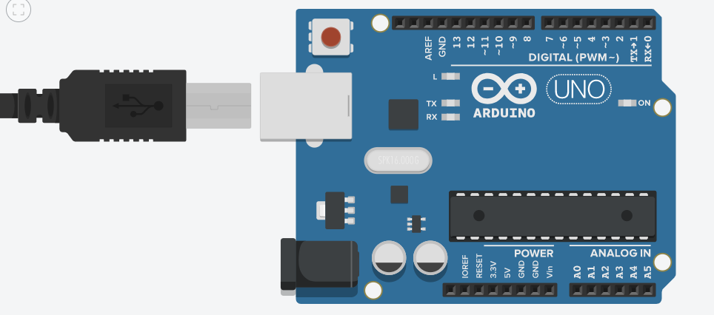

**Running Project Image:**

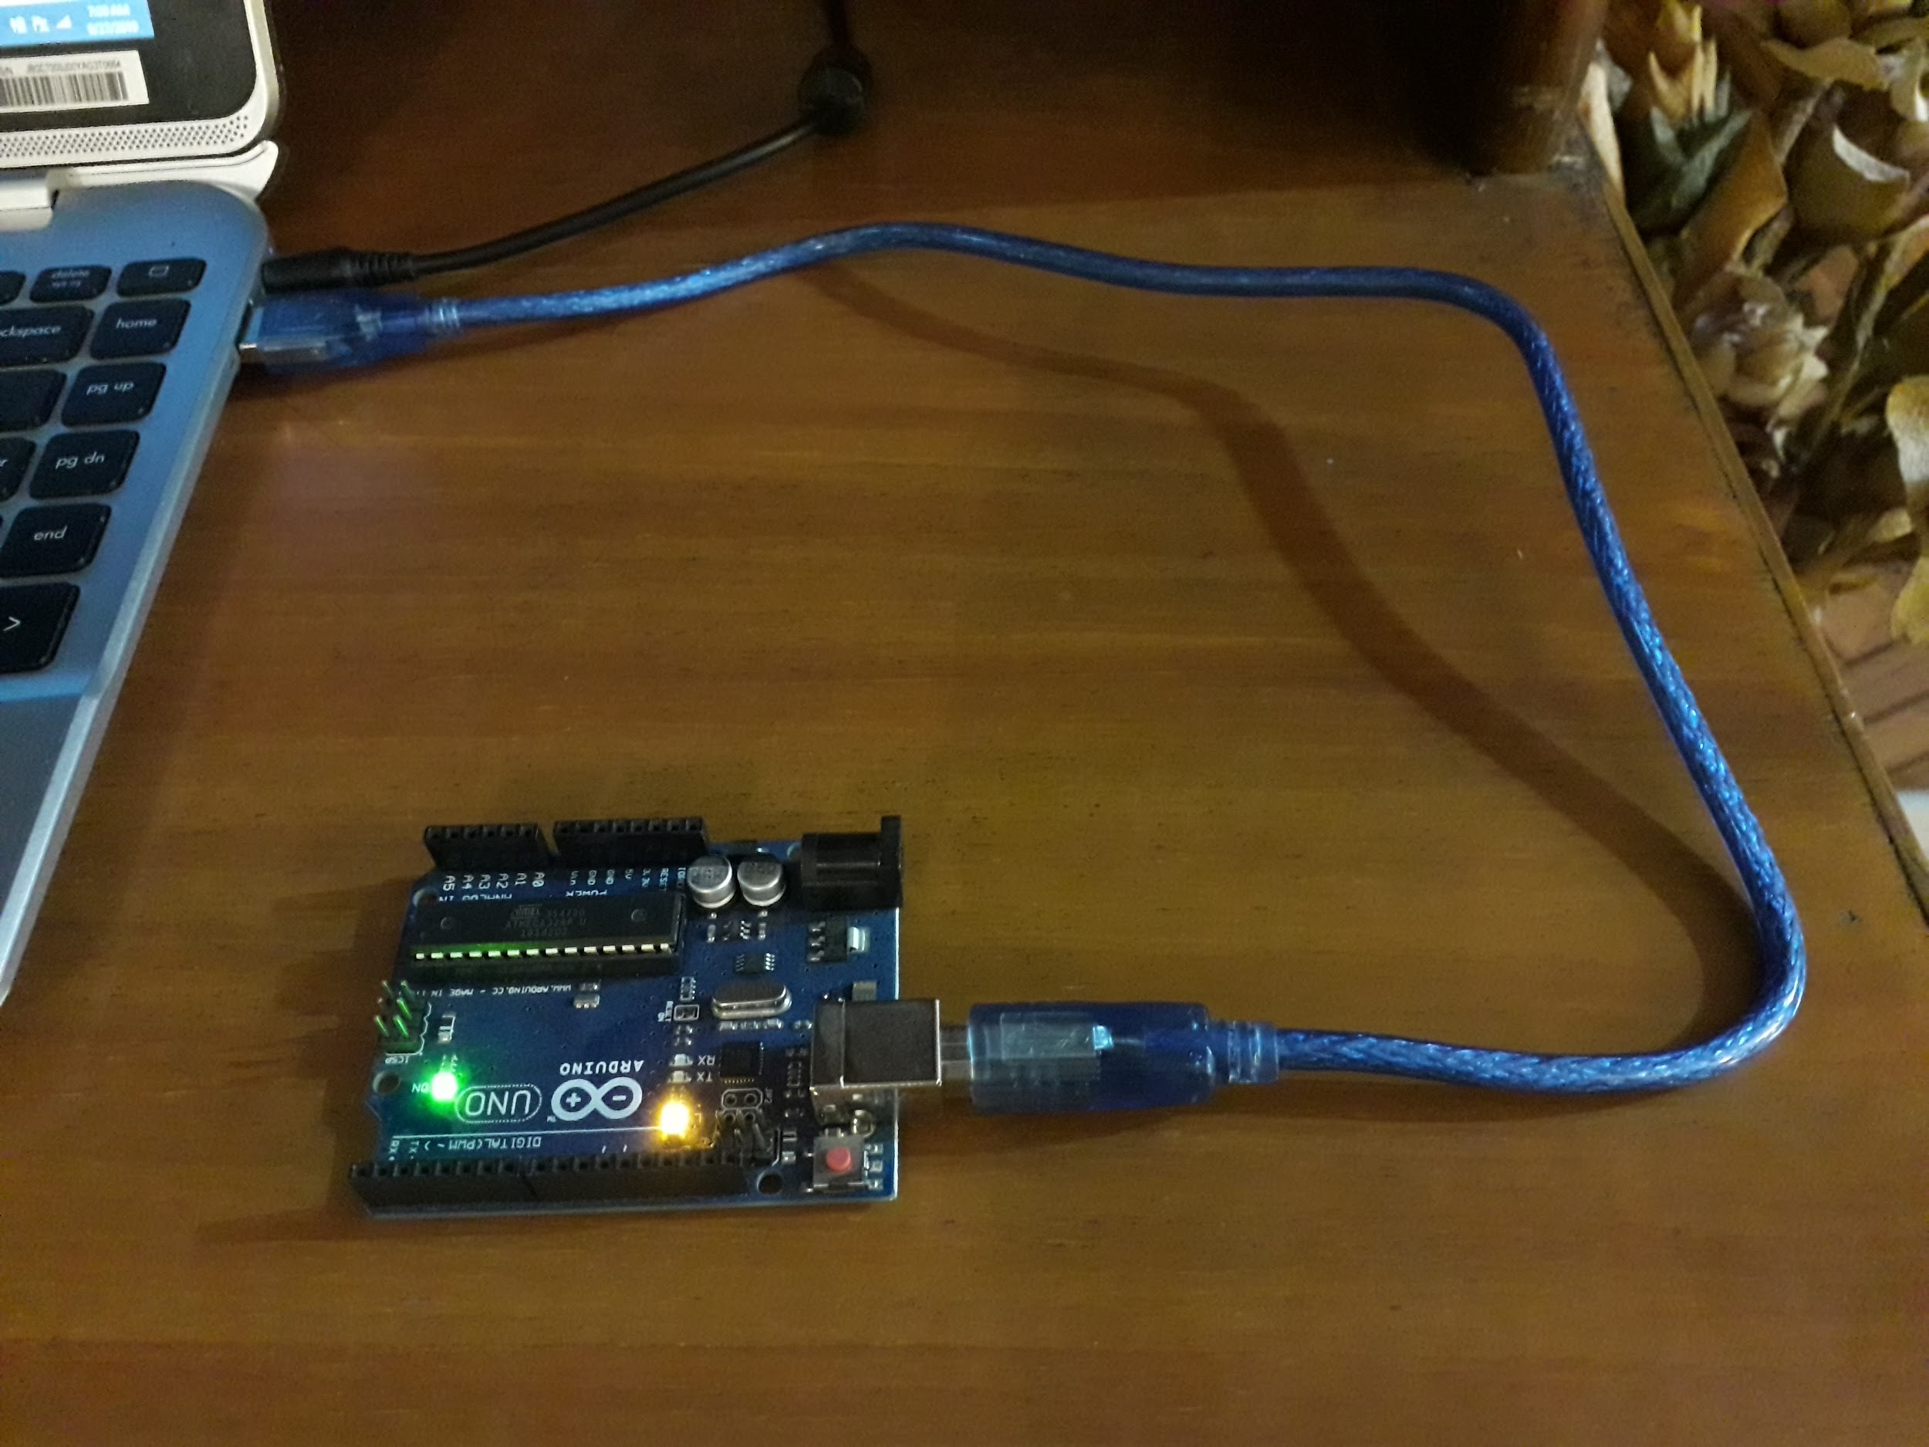

**Running Program Screenshots:**

**LabTask1:**

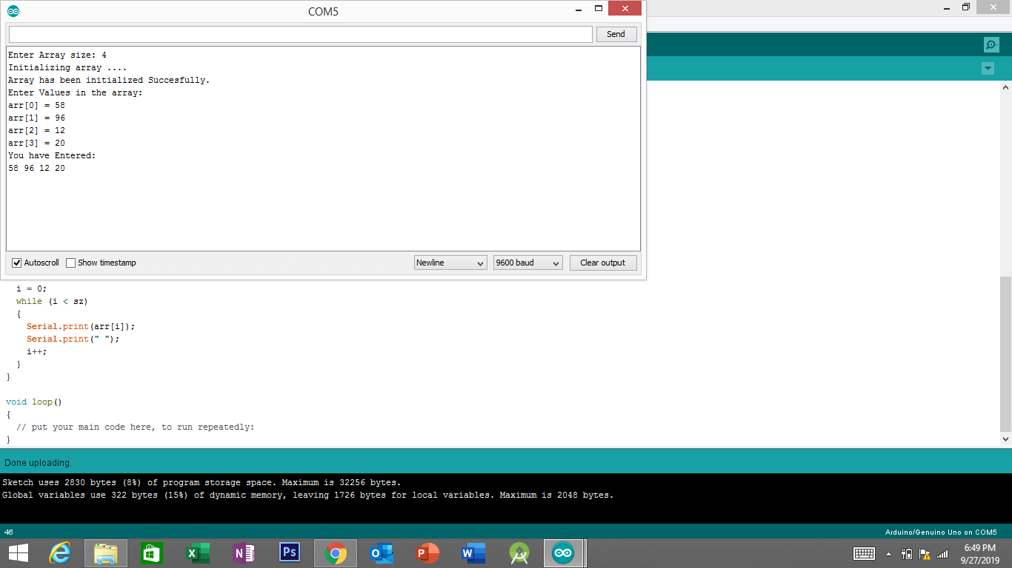

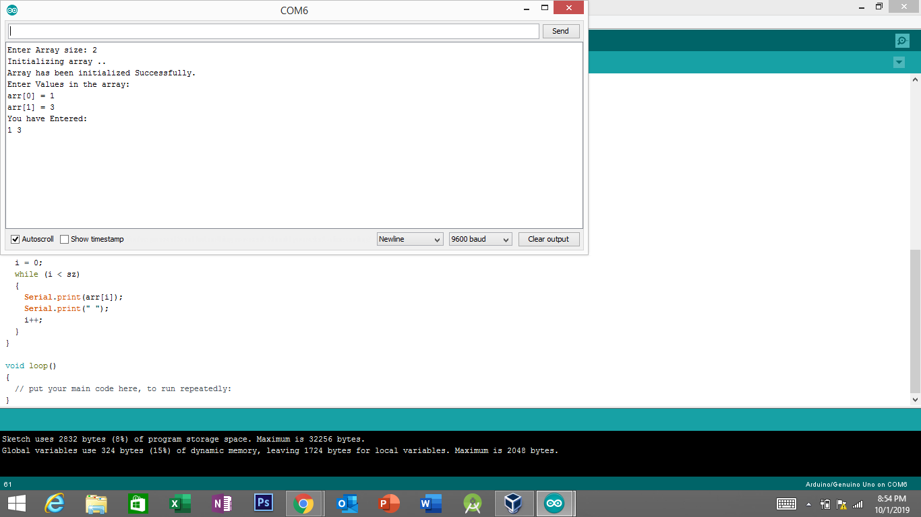

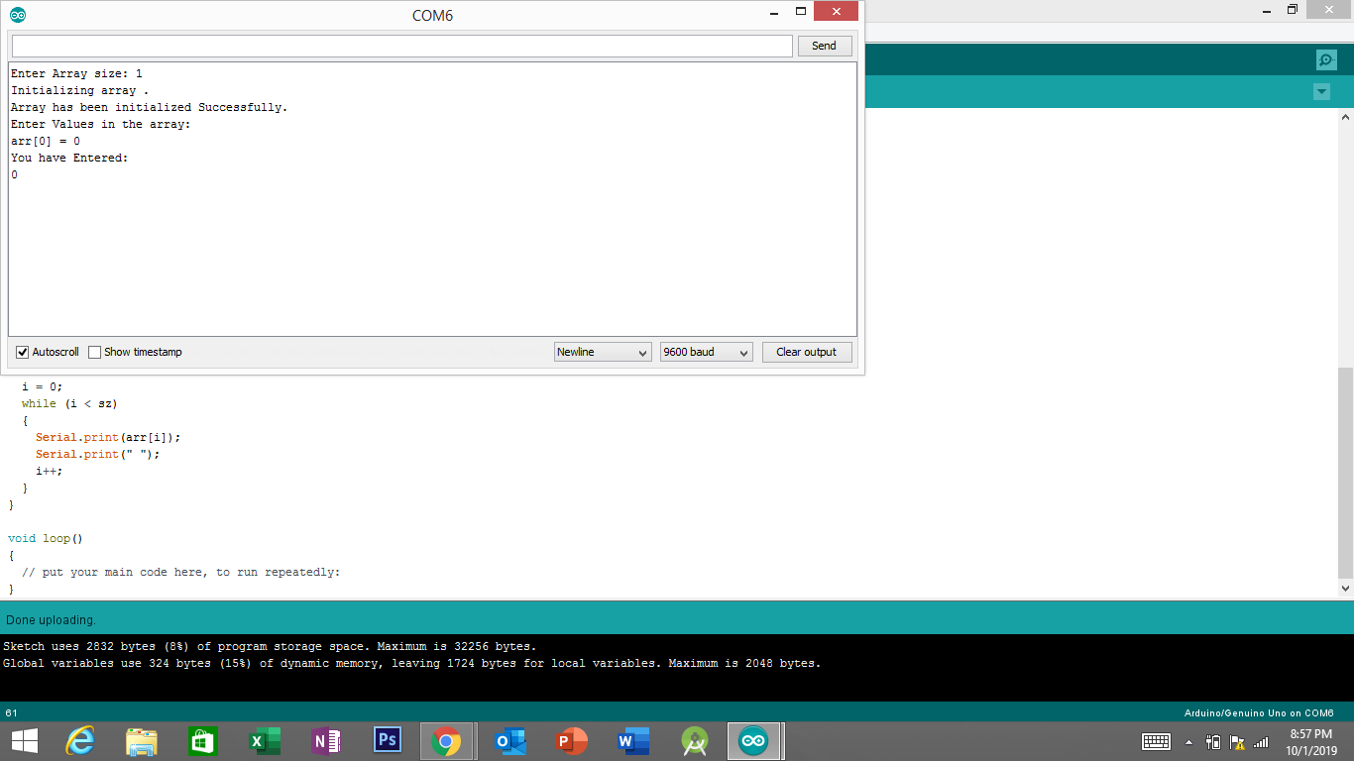

**LabTask2:**

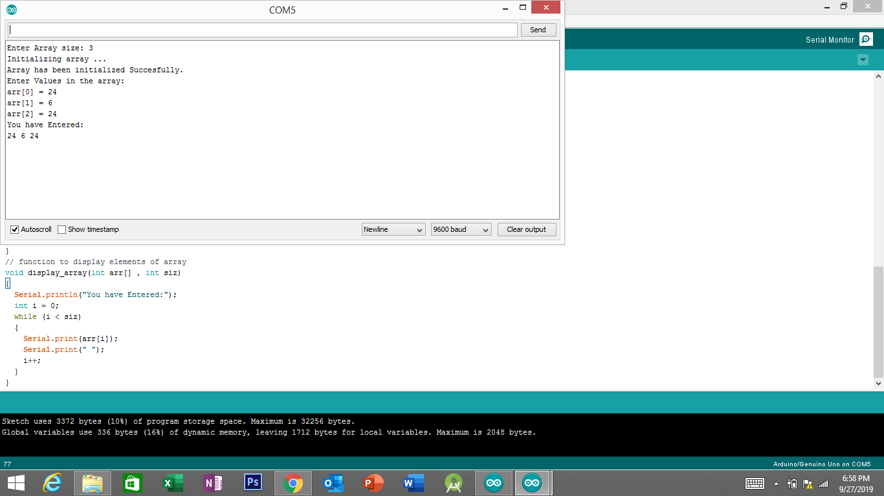

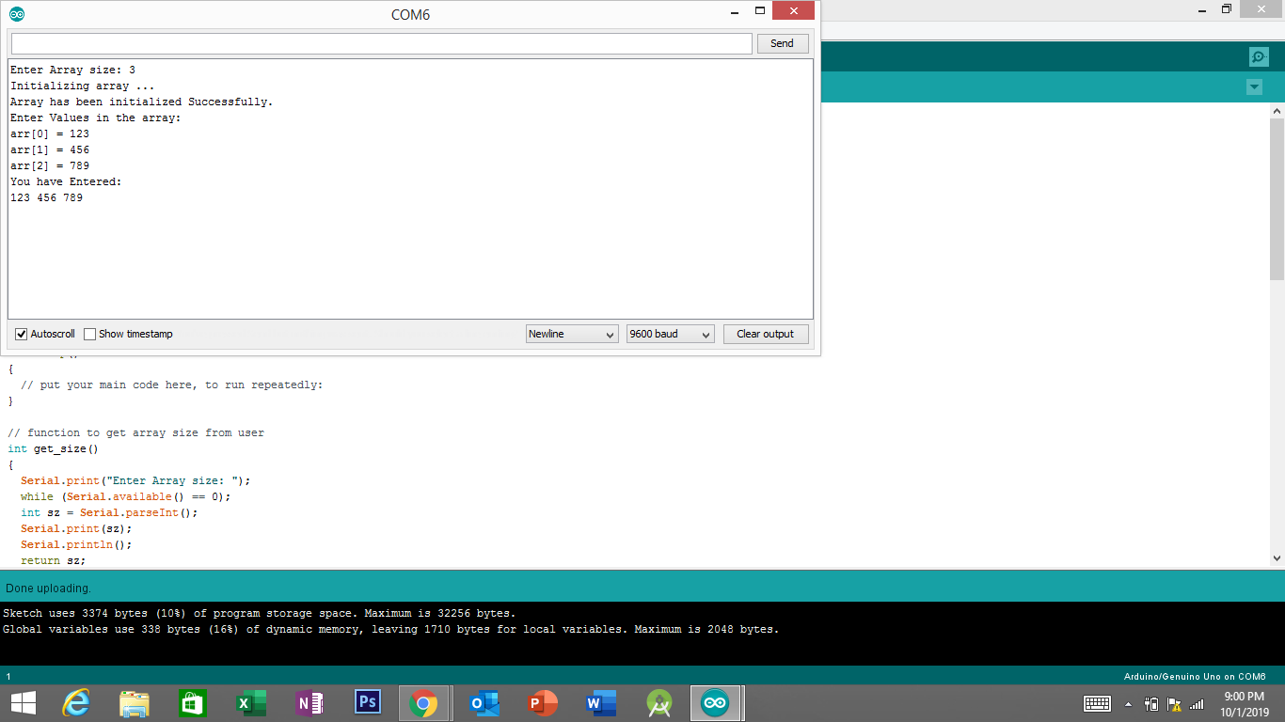

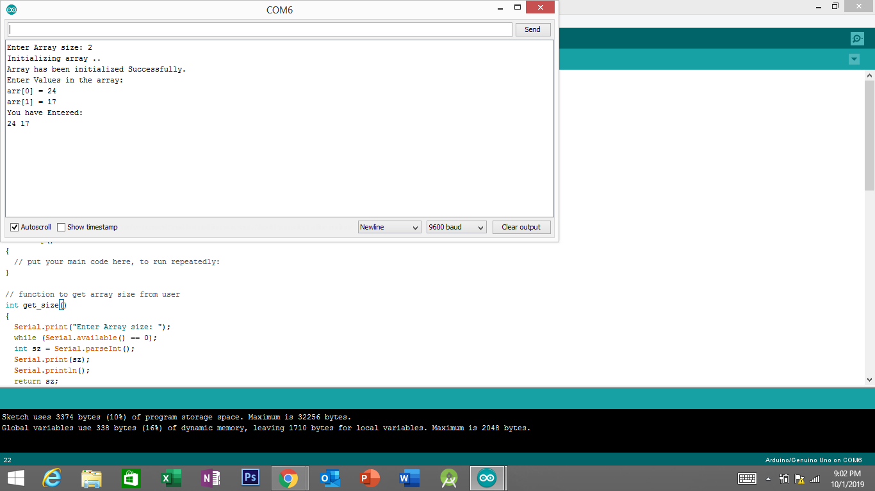

**LabTask3:**

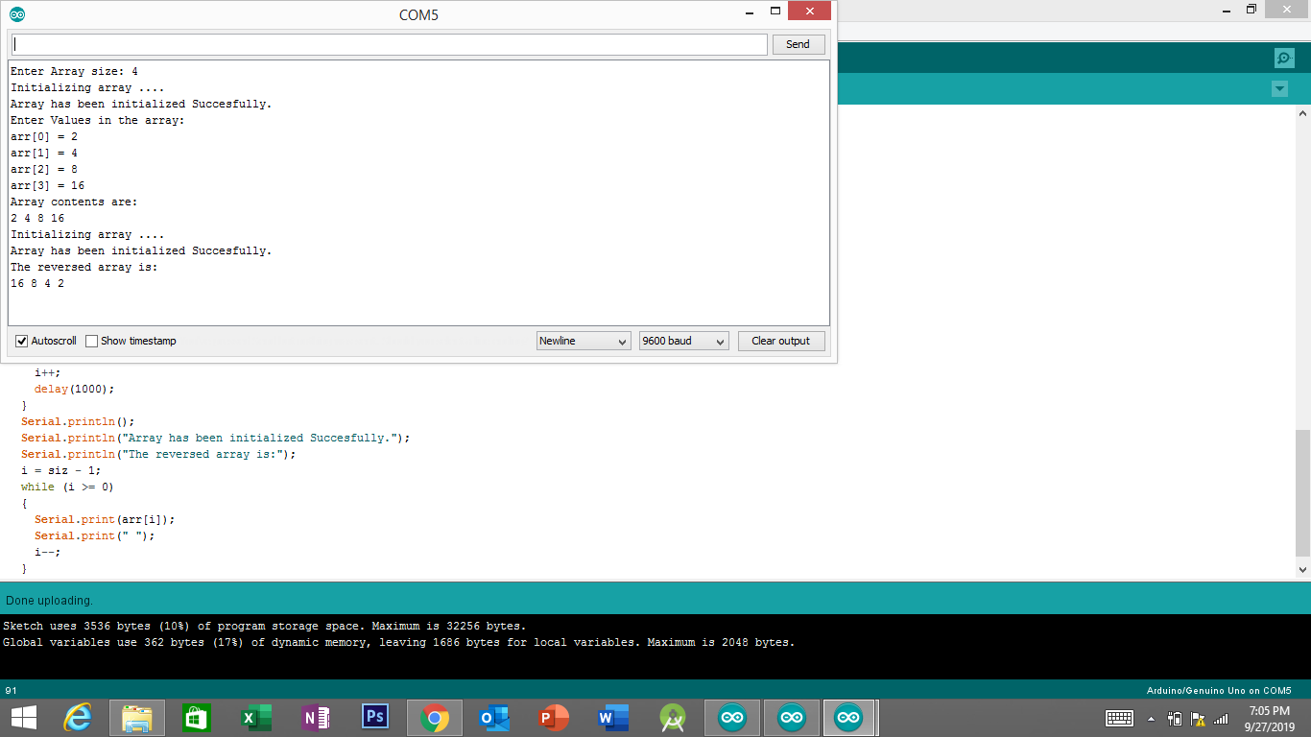

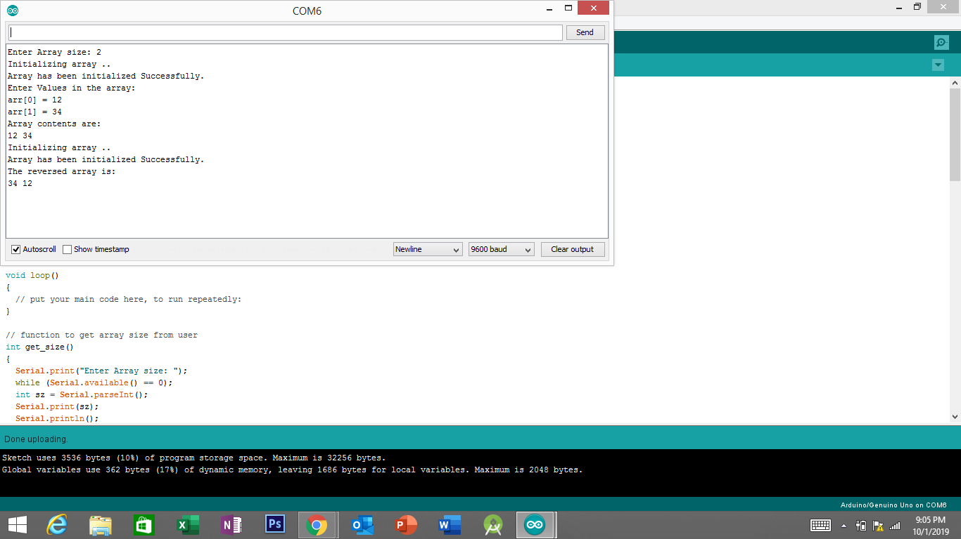

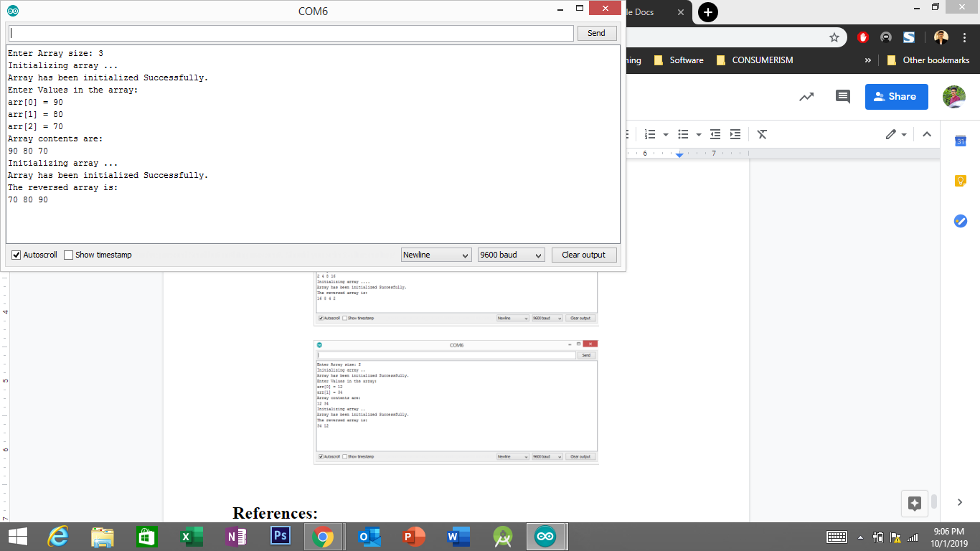

**References:**

* <https://www.arduino.cc/reference/en/language/functions/communication/serial/println/>
* <https://www.arduino.cc/en/Serial.ParseInt>
* <https://arduino.stackexchange.com/questions/48526/serial-parseint-value-always-goes-back-to-0>